

Walchand College of Engineering, Sangli.

(An autonomous institute)

&

Electronics Engineering Students’ Association (ELESA)

Presents

ELECTROVERT 2016

The Performers’ creed

Website: [www.elesa.in](file:///C:\hitesh%20docs\engg\ELESA15-16\ELECTROVERT15\JD\www.elesa.in)

Email: [electrovert2016@gmail.com](mailto:electrovert2015@gmail.com)

ELECTROVERT 2016

EVENT STRUCTURE

ELECTROVERT 2016

EVENT Structure

ELECTROVERT is a **State Level Technical Event** organised by Electronics engineering students’ associations (ELESA) a technical club of Walchand College of Engineering, Sangli established in the year 1992. ELESA have 52 board members from different years of Electronics Engineering.

As per the tradition of ELESA after successful glory and overwhelming response of students. ELESA is organising ELECTROVERT 2016.

Theme of ELECTROVERT 2016: **Border Security**

Attraction of ELECTROVERT 2016: **ELECTROCHAMP**

ELECTROVRT 2016 will consist of following sub events:

|  |  |  |
| --- | --- | --- |
| Sr.No | **Sub Event** | **Date** |
| **1** | **Pro-kriti** | **1st day of Event** |
| **2** | **µ-Krieg** | **1st day of Event** |
| **3** | **Circuit’O\_FReak** | **1st day of Event** |
| **4** | **Trigger It** | **1st day of Event** |
| **5** | **Candor(Paper Presentation)** | **2nd day of Event** |
| **6** | **Proyecto** | **2nd day of Event** |
| **7** | **Negotium** | **2nd day of Event** |
| **8** | **Quiz** | **2nd day of Event** |
| **9** | **ELECTROCHAMP** | **2nd day of Event** |

The **OBJECTIVES** of the ELECTROVERT are

* To Encourage creativity of the students by nurturing their ideas and inducing the feeling of social binding
* To impart industrial knowledge within the students by arranging different technical events and Guest Lectures and to enhance employability of the students to work in core Electronics industries.

Along with above mentioned objectives this year we have the **OBJECTIVE** of the ELECTROVERT 2016 is to encourage students for developing new technologies as well as to find out solutions of problems about security issues.

To achieve these objective as mentioned earlier the brief introduction and structure of ELECTROVERT 2016 is as follows

**1. Pro-kriti:**

This sub event is based on electronics circuit designing software “Proteus” which is also helpful for PCB designing and simulations of basic analog and digital circuits. It is organised on the first day of the event. We are expecting 40 teams for this sub event. Each team will consist of two students.

This event is helpful to check the ability of the participants to deploy the various facilities available in PROTEUS simulator for the advanced learning and understanding of the concepts in electronics.

In this event there will be 2 rounds.

**ROUND 1:**

Simple aptitude test containing 40 questions for 30 minutes. The aptitude test will contain

|  |  |  |
| --- | --- | --- |
| Digital | 1.Sequential circuits  2.Combinational Logic  3.Boolean Algebra | 15 Question |
| Analog | 1.Clipper and clamper  2.Network Analysis  3.BJT circuits | 15 Questions |
| Proteus | 1.Shortcuts  2.Error finding  3.Basics | 10 Questions |

**ROUND 2: (Problem assessment and simulation)**

5 questions for simulation 2 from analog, 2 from digital and 1 based on proteus software.

**2. µ-Krieg:**

As we all know microcontroller is heart of electronics. In ELECTROVERT2016 we are going to organise one sub event based on programming of microcontroller. This sub event is organised on the first day of the event. We are expecting 80 teams for this sub event. Each team will consist of 2 students.

This event is helpful to check programmability of students for specific controller and fluency for embedded languages. In this event there will be 3 rounds

**Round 1: (Aptitude test)**

Aptitude test based on simple questions based on architecture interfacing of microcontroller. Containing 35 questions for 30 minutes.

**Round 2: (Simple programing)**

8 problem statement each for 5 marks based on simple interfacing and memory related operations, complex interfacing and interrupt protocol each for 10 marks.

**Round 3: (Complex Problem statement)**

1 Problem statement for 1 hour related to SECURITY problems.

**3. Circuit’O\_FReak:**

The crucial part in Electronics engineer’s life is circuits so we are organising a sub event based on circuit building. We are expecting 60 entries for this sub event held on the first day of the event. For this event we are going to give specific analog or digital circuit to participants which they have to build.

From this event command over studies of different subjects will be checked because for designing and building circuit deep knowledge and study of curriculum subjects is necessary.

For this event there will be two groups i.e. novice and expert. For novice group first year, second year from degree and diploma will compete among them. And for Expert group remaining years from degree and diploma will compete.

In this event there will be 2 rounds.

**Round 1: (Aptitude test)**

Different aptitude test for expert and novice and will maintain difficulty level according to group.

**Round 2: (Circuit Building)**

Problem statement will be provided difficulty depending on group participants have to design circuit and then build it actually with components provided.

**4. Trigger It:**

As per tradition of ELESA every year we organises a special event for first year students which encourage them to express themselves. The objective of this event is to find hidden talent in the new generation engineering. As level of competition will be same the more and more innovative mind will introduced here.

We are expecting 80 teams for this event and in every team there will be two members. This event will be on the first day of the event.

This event will help to ignite the spark of innovation in new generation which will result into excelling brilliance in future.

In this event there will be 3 rounds.

**Round 1: (Aptitude test)**

Difficulty level will be as compared to first year students questions will be based on quantitative aptitude, Verbal aptitude, Logical Reasoning, General Knowledge.

**Round 2: (Presentation)**

This round will consist of Group discussion, Situation Analysis.

**Round 3: (Rapid fire and Buzzer)**

This round will based on rapid fire questions and buzzer round which will help to check ability of students for quick response.

**5. Candor (Paper Presentation):**

This event is paper presentation event which will be organised on the second Day of event. This event will be basically consisting of two rounds. We will give participants a theme, and they have to present a paper on a subject related to that theme by considering the rules of International Paper Presentation.

Shortlisted participant will move further for the second round where there presentation skill will be judged.

We are expecting 40 to 45 entries for this event as this is first time organized in the ELECTROVERT.

**6. Proyecto:**

This event is project presentation competition. In this event we have two sub types. *Inventors* in this type students will present their own project to the judges and *Creators* for this type ELESA will assign problem statement on which participants have to develop their project. This event is organised on the second day of the event and each team will consist of 4 members. We are expecting 35 teams for this sub event.

This event will support our theme because of *Creator* problem statements.

**7. Negotium:**

As said in ELESA’s objective we always try to develop technical as well as management skills. In ELECTROVERT we organize management event such as *NIFTEX, OFFERTA* based on share marketing bidding respectively. From this event we try to enlighten the management skills of the participants.

This year theme of this event is product designing with trending technologies for this product designing participants have to buy that technology by bidding it so that students will get to know about bidding strategies and product designing after that they have to market their designed product it will improve marketing skills of participants. We limit the entry count for such management event to 40 and 2 members in each team. This event is organised on the second day of the event.

**8. Quiz:**

This event is organised on the second day of the event. Where we expect huge response of about 80 entries.

This event will be consisting of three rounds.

**Round 1: (Aptitude test)**

The test will be conducted based on the general knowledge of participants. There awareness about the current affairs will be checked. There will be shortlisting.

**Round 2:**

This will be a kind of rapid fire round. Here participants will have to answer the questions from different fields like Politics, Sports, History, etc.

**Round 3:**

This will be a buzzer round. Time and Points will decide the winner.

**9. ELECTROCHAMP:**

This year’s main attraction will be ELECTROCHAMP. This year ELECTROCHAMP is open to all. Each team comprised of 3 participants. They will work on a problem statement related to BORDER SECURITY ISSUES for 8 hours on the second day of the event. Before 5 days these teams will be provided with the task and shortlisted for the second round depending upon their performance. These teams will be provided with a mentor from ELESA and an expertise to help them. At the end of day they have to present their research on that problem statement and have to come up with an implementable solution.

From this event ELESA want to give the feel of company environment to the participant.

Previous years’ ELECTROVERT Details

* **PROTEUS Software simulation contest:**

This sub event is based on simulation of analog and digital circuit on proteus simulation software also Proteus can be used for designing PCB (Printed Circuit Board). The main motto behind this sub event is to create awareness about simulation software. Through this event we checked the ability of the participants to deploy the various facilities available in Proteus simulator for the advanced learning and understanding of the concepts in electronics.

Here are some details of entries for last four year of ELECTROVERT.

* **Microcontroller and microprocessor programming based contest**

Microprocessor and microcontroller are the back bone of embedded system. It is one day programming contest, based on 8051 microcontroller and 8085 microprocessor.

The main motto behind this sub event is to check the proficiency of students in the embedded system, programmability with various controllers and processors.

Here are some statistics of previous ELECTROVERT.

* **Circuit Building competition:**

As transistors are the heart of electronic stream so we organised a circuit building competition. This event was consisting of a digital electronics as well as analog electronics. We provided participants with the design problem statement which they had to design and then build it on breadboard within time allotted. Components required for circuit, were provided.

Here is graphical representation of entries for circuit building.

* **Project Presentation Competition:**

As mini project and mega project became the main part of every academic year. We organised a competition based on a project presentation. The main motto behind this event to encourage the students to enhance their creativity in project building and they should be able to overcome the various problem faced by industries.

Statistics from previous ELECTROVERT:

* **Exclusive event for First year students:**

This event was organized exclusively for First Year Engineering Students. The prime purpose behind organizing this event was to provide first year students with a platform where they can show and affirm their knowledge, command over language and versatility. Efforts were made to make this event informative and interactive.

* **Management Event:**

As ELESA look after overall development of student. There should be support of management skills to technical skills. To enlighten management skills of students since last three years ELESA organising management event.

Statistics of management event: Entries of management event were limited.

* **Paper presentation Event and QUIZ:**

Now days all want to be successful in our life. To become successful we should possess some good qualities which will lead us towards the heights of success one of them is presentation skill. And an engineer must possess technical knowledge without which one can not survive. And this is judged by quiz.

These two events are introduced for the first time in the ELECTROVERT.

|  |  |
| --- | --- |
| C:\hitesh docs\engg\ELESA15-16\ELECTROVERT15\JD\JD_IMAGES\DSC02987.JPG | C:\hitesh docs\engg\ELESA15-16\ELECTROVERT15\JD\JD_IMAGES\DSC02977.JPG |
| Inauguration Ceremony | |
| C:\hitesh docs\engg\ELESA15-16\ELECTROVERT15\JD\JD_IMAGES\06102012037.jpg | C:\hitesh docs\engg\ELESA15-16\ELECTROVERT15\JD\JD_IMAGES\06102012047.jpg |
| Online aptitude test for some events | |
| C:\hitesh docs\engg\ELESA15-16\ELECTROVERT15\JD\JD_IMAGES\20130921_104257.jpg | C:\hitesh docs\engg\ELESA15-16\ELECTROVERT15\JD\JD_IMAGES\06102012062.jpg |
| Paper Pen aptitude test for some events | |

Some Captured Moments from Previous ELECTROVERT

|  |  |
| --- | --- |
| C:\hitesh docs\engg\ELESA15-16\ELECTROVERT15\JD\JD_IMAGES\20130921_173601.jpg | C:\hitesh docs\engg\ELESA15-16\ELECTROVERT15\JD\JD_IMAGES\20130921_165118.jpg |
| Social activity event at orphanage. | |
| C:\hitesh docs\engg\ELESA15-16\ELECTROVERT15\JD\JD_IMAGES\20150110_152411.jpg | C:\hitesh docs\engg\ELESA15-16\ELECTROVERT15\JD\JD_IMAGES\06102012056.jpg |
| Huge response by alumina and participants. | |
| C:\hitesh docs\engg\ELESA15-16\ELECTROVERT15\JD\JD_IMAGES\DSC03004.JPG | C:\hitesh docs\engg\ELESA\electrovert 12\priya\101MSDCF\DSC03008.JPG |
| Prize distribution ceremony. | |

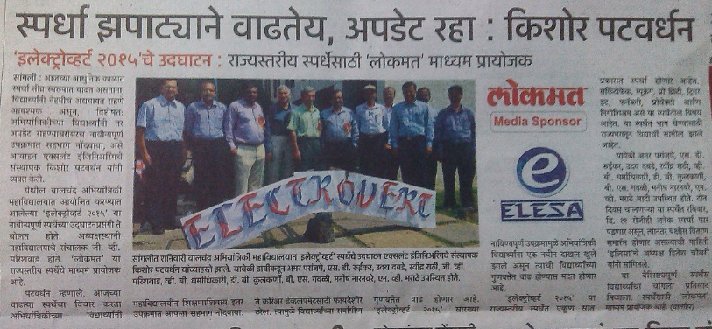

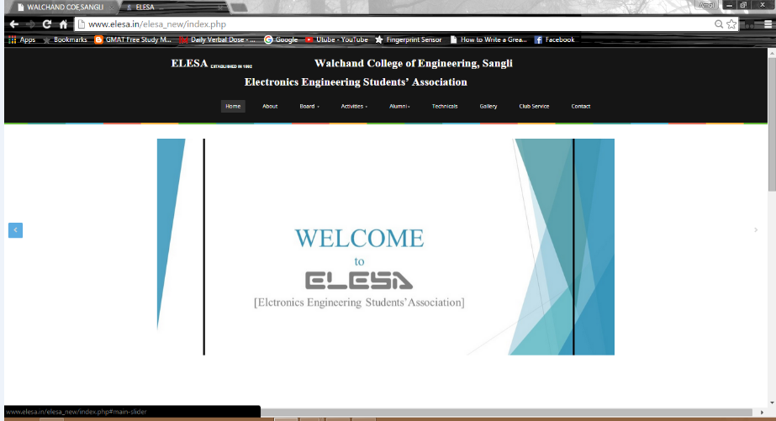ELECTROVERT News in News Paper

New ELESA website